Locked Me

LockedMe.com. The whole project was divided in 2 Sprints of 1 week each.

1st Sprint:-

Added the method to Create a user defined file.

Added the method to list all the file in the directory where these user defined file will be stored.

Created a main method with these method called to call create and list method on the base of user given command from the menu shown to user

2nd Sprint:-

Added a method to delete any existing file which user commands to.

Added a method to read and render the content of the file asked by user.

Modified Create method to get user defined content too.

Modified main method to render the list in a loop until user wants to exit the operations.

Methods and operations:-

We have 5 operations that user can perform.

1st :- Create a file and add content to it.

2nd :- Read any file.

3rd :- delete any file.

4th :- List all the files.

5th :- Exit the application.

To refer, see the screenshots below

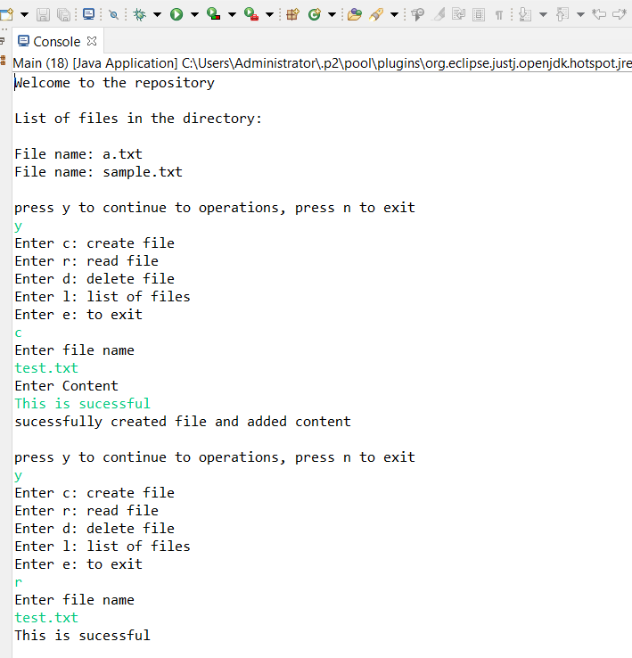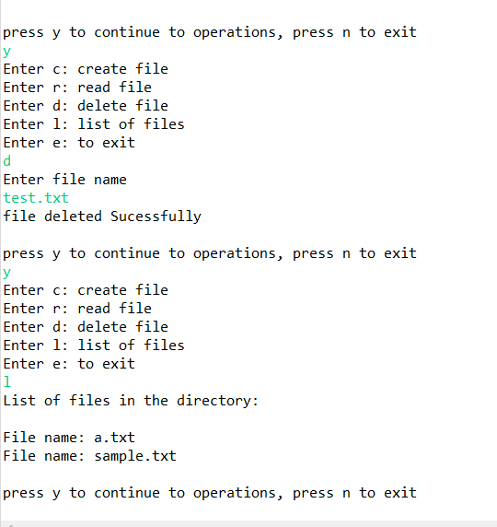

Code Module

The code was divided into 2 class:-

1st:- Main

This class had just one method, main method which had the logic to loop and render the content and the interaction part with the user.

2nd:- Operations

This class had 4 methods createFile, readFile, deleteFile and listFile. Each method had their task assigned as the name suggests.

Refer images below to see the code snippets

